|  |
| --- |
|  |
| ROM Calibration Tool - Setup |
| Version 0.1 |
|  |

|  |
| --- |
|  |

Contents

Revision History 2

1. Development Framework Installation 3

1.1. Installing Qt 3

1.2. Online Installation 3

1.3. Offline Installation 3

2. RTC Environment 4

3. Build & Run ROM calibration Tool 5

3.1. Create a local work space of the “JLR_TOOLS” RTC stream. 5

3.2. Load the ROM calibration tool Qt project into Qt creator IDE by browsing the 5

3.3. The ROM calibration tool Qt project will be opened as shown in the below image. 6

3.4. Select the build configuration type (Release/ Debug). 7

3.5. Start the compilation. 8

3.6. Run the application. 9

3.7. Application GUI will be opened up as shown in the below image. 10

# Revision History

|  |  |  |  |
| --- | --- | --- | --- |
| Rev | Date | Modified By | Contents |
| 0.1 | 04-Feb-2019 | Anil Joseph | Initial version. |
|  |  |  |  |

# Development Framework Installation

The ROM calibration tool is developed using Qt C++ framework. Please follow the below mentioned steps to install the latest version of Qt Framework.

## Installing Qt

You can install the Qt Framework and tools by using an [online](http://doc.qt.io/qt-5/gettingstarted.html#online-installation) or [offline](http://doc.qt.io/qt-5/gettingstarted.html#offline-installation) installer, or by [building the source packages yourself](http://doc.qt.io/qt-5/build-sources.html).

The installers allow you to download and install the following components:

* Qt libraries, prebuilt for a particular development platform (operating system and compiler)
* Qt Creator integrated development environment (IDE)
* Reference Documentation and examples
* Qt in source code form (needed only if you want to build the framework and tools yourself)
* Add-On components that are relevant for different platforms

## Online Installation

In the *online installer*, you can select commercial or open source versions of Qt, tools, and Add-On components to install. Using the online installer requires signing in to your [Qt Account](https://account.qt.io/). The installer retrieves the license attached to the account from a server and provides a list of available components corresponding to the license.

The online installer is available from the Qt [Downloads](http://qt.io/download) page.

## Offline Installation

An *offline installer* is a single package that contains all of Qt and Add-Ons relevant for a target platform. Users with a commercial license can either sign in with their Qt account or with their Qt license key during the installation process. The license key is available in the [Qt Account](https://account.qt.io/) Web portal.

# RTC Environment

**RTC Project Area :** JLR IC EU

**RTC Stream :** JLR_TOOLS

**RTC Component :** di-jlr-rom-calibration-tool-vip

**Compiler :** Qt can work with both MinGW & MSVC compilers.

By Default Qt comes with MInGW compiler and the compiler will be installed under the ‘Tools’ folder in Qt installation directory. For ex: (C:\Qt\Tools\mingw530_32)

**IDE :** Qt Creator – Version 4.6.2 or above

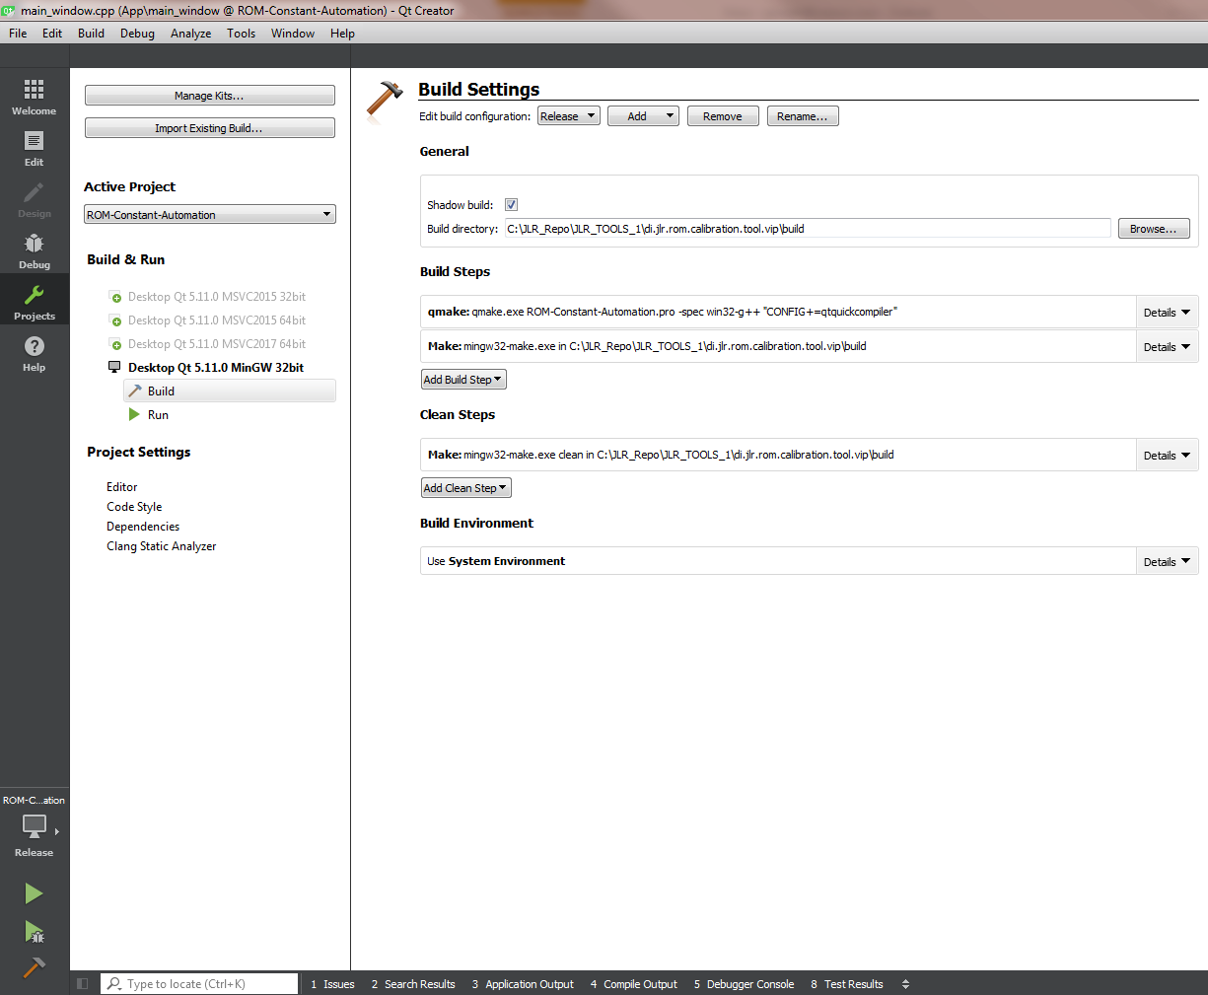

# Build & Run ROM calibration Tool



## Create a local work space of the “JLR_TOOLS” RTC stream.

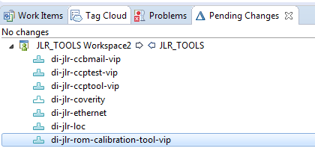

## Load the ROM calibration tool Qt project into Qt creator IDE by browsing the

QT project file.

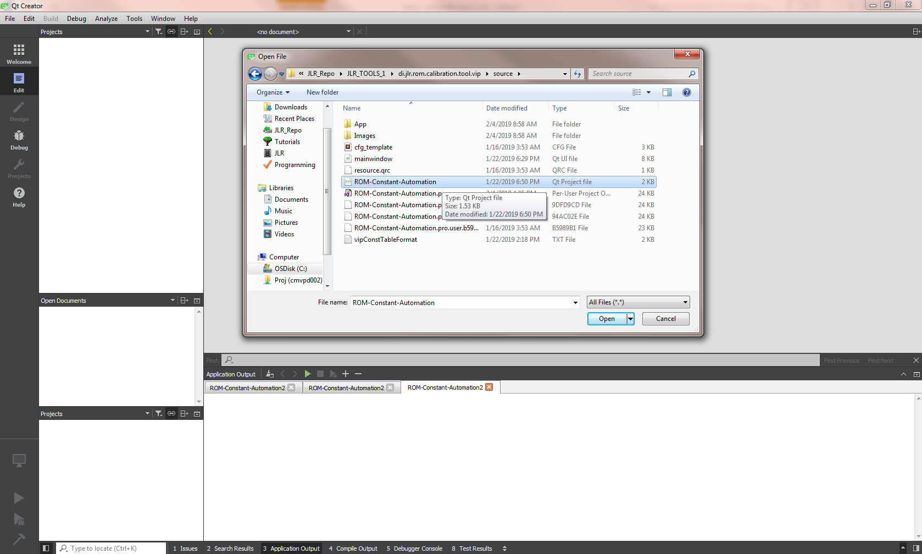

## The ROM calibration tool Qt project will be opened as shown in the below image.

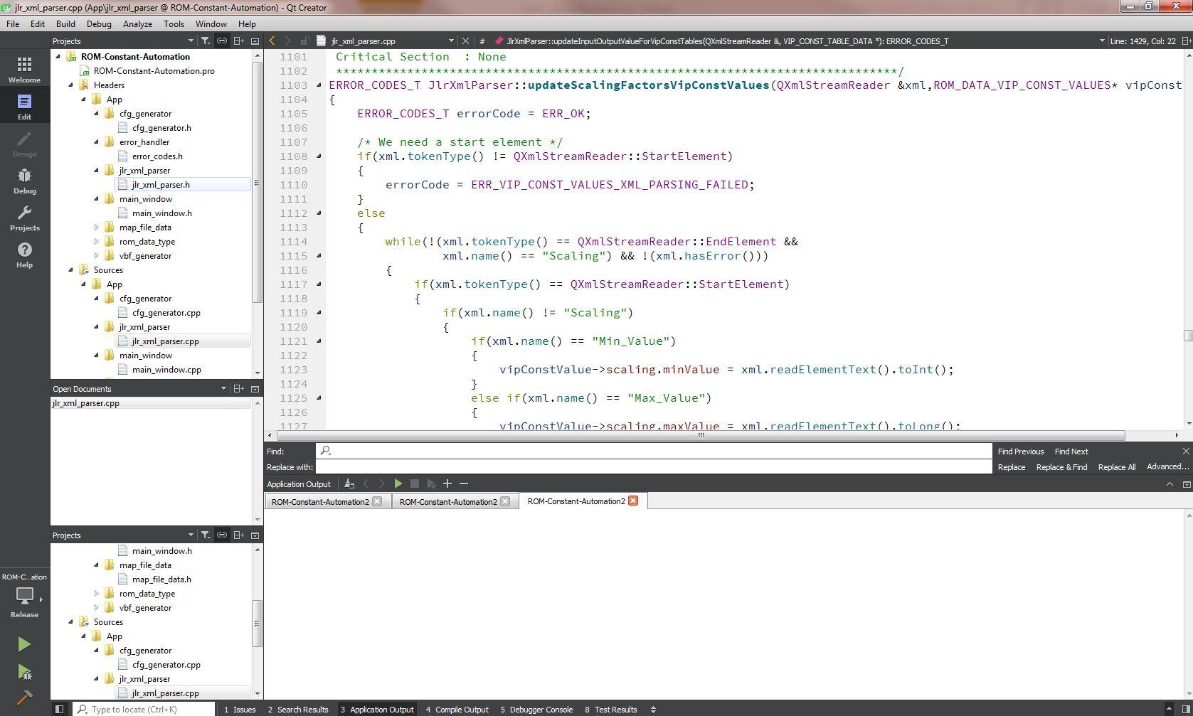

## Select the build configuration type (Release/ Debug).

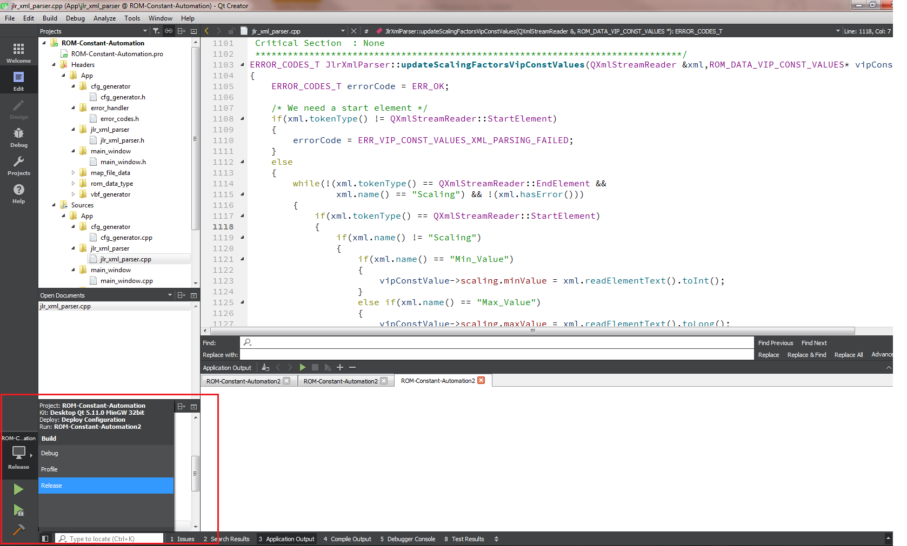

## Start the compilation.

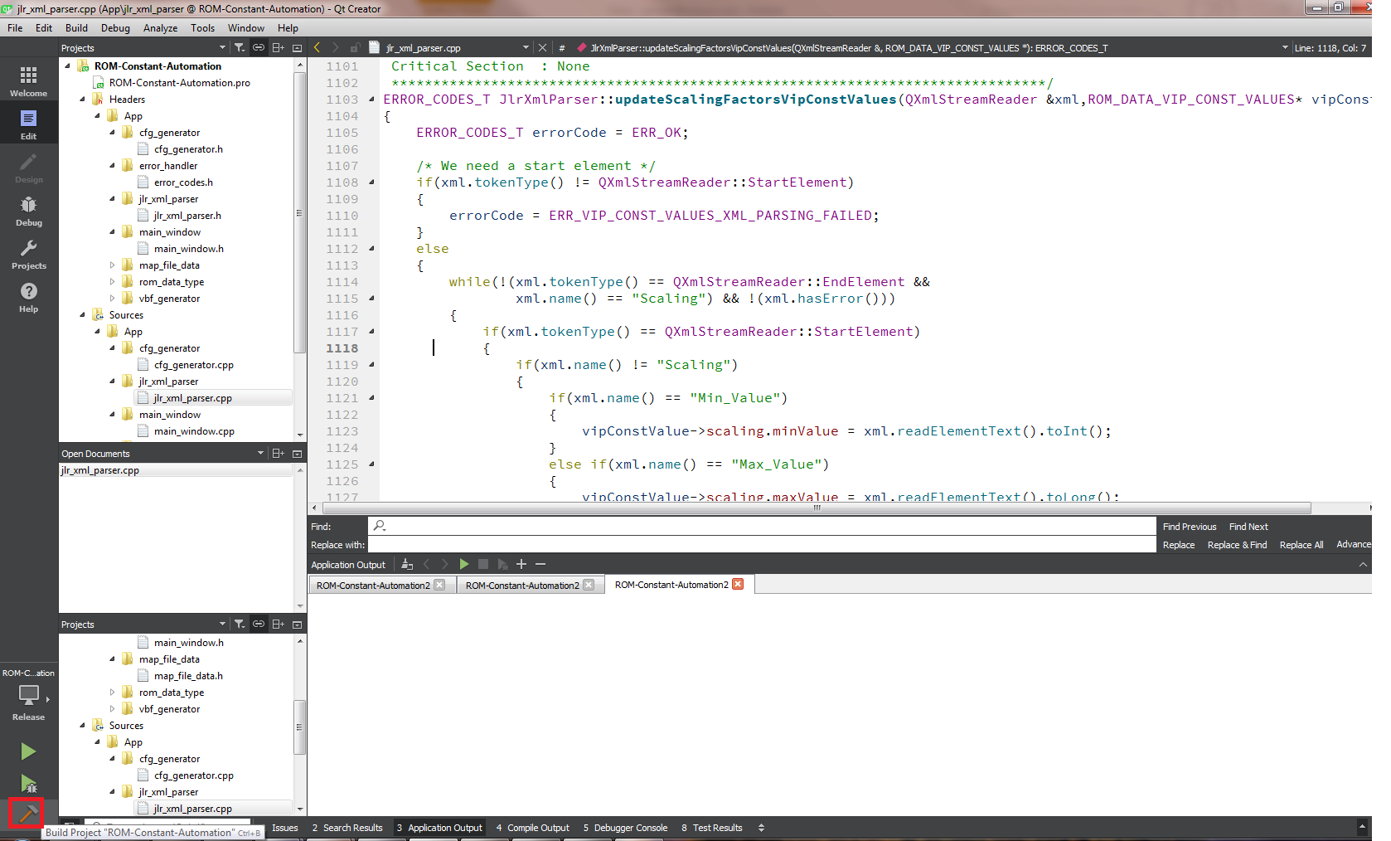

## Run the application.

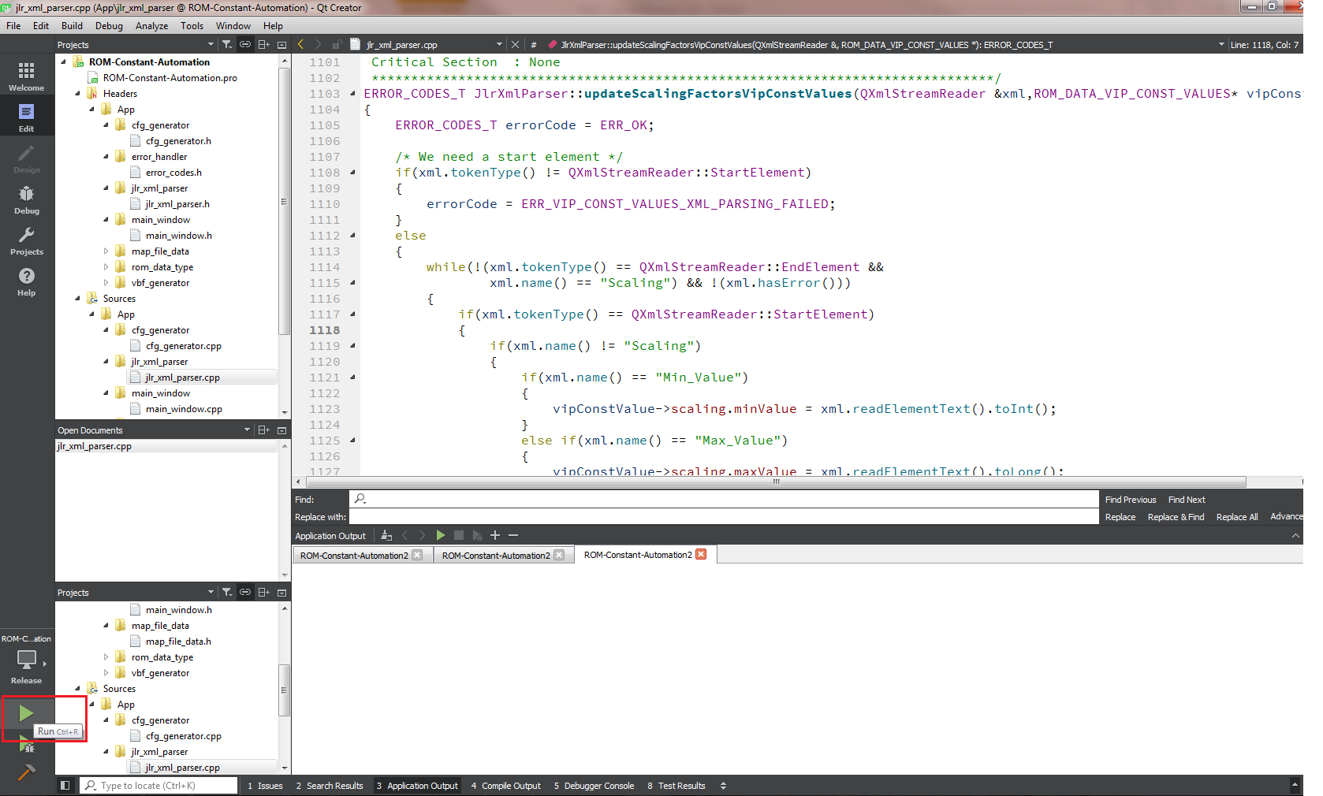

## Application GUI will be opened up as shown in the below image.

